K.H.U. Faculty of Engineering and Natural Sciences

IT 400 BACHELORS PROJECT
PROPOSAL

EXPLORING AGILE METHODOLOGIES & ITS RELATION TO PROJECT MANAGEMENT

Project Advisor: Ebru Dilan & Mehmet Nafiz Aydın

Project Team:

Tevhide Sena Tarımcı - Information Technologies
Aslıhan Kalaycı - Information Technologies

Submission Date: 11.12.2014
ABSTRACT:
Scrum is a framework and an agile approach for project management and it is used for building teams, beating deadlines and boosting productivity. In this project we will deal with the principles and characteristics of Scrum and comparision with other traditional waterfall project management approach and also we will focus on how it is implemented in an organizational environment.We focus on the comparision between Scrum and its relation with waterfall models in the stable organization and software development processes of the firm. For better understanding we will studied case of Turkish Telecomunication firm.(YİTMEN,2000)

AIM:

Our aim is to understand Scrum and it’s implementation in an organization. We will focus on 3 different levels for better understanding of organization’s agile & Scrum experience. In the first level, we will focus on how company will transform the waterfall methods to Scrum and other agile methods and before the agile which techniques are used by them. (Organizational structure, roles, responsibilities)
In the second level ; how to implement Scrum in a project, the steps to focus on and it’s implementation. To understand all these things we will focus on specific project. In the last level, we will explore the personal experiences.

METHODOLOGY:

- Literature review: We need to look at existing reseach that is significant to our project.And we need to evaluate the results so we can have a chance to see different works and relationships with our subject. To review a literature ; we need to know what to do , which subject we need to look at
- Qualitative approach: While we are doing qualitative research we will look in –depth at non numerical data (Mack, N., Woodsong, C., MacQueen, K. M., Guest, G., & Namey, E. 2005)

- Case study : While doing case study we have a chance to study one aspect of a real-world problem in detail and we have a chance to see many different viewpoints.
- Data collection:During the case study research we will collect the data first. And try to make sense for our project. For collecting these data we will do interview (with different roles) and review project documents in organization.
- Data analysis: To analyze the interview result, keyword analysis will be used.
- Findings will be given in a summary table

WORK PACKAGE DESCRIPTION

GRADUATION PROJECT
PM
Application for submission
Writing proposal
Develop project schedule
CONCEPTION
Determine initial title
Define research problem
Determine methodology
LITERATURE REVIEW
Searching for relevant studies
Reviewing relevant articles
CASE STUDY
Making Interviews
Analysing Interview Results
Review Project Documents
RESULT
Table of Contents
Case analysis
Findings
Conclusions
Introduction
Finalizing research title
Abstract/Keywords
Final Report Submission

WORK PACKAGE DESCRIPTION

Number and name of the package:1st packet Project Initiation and Planning

Start date:14 November 2014

Finish date: 18 November 2014

Short description: In this packet we will do Application for submission , Writing Proposal & Develop project schedule

Methodology: In this packet we will create our project plan and create work package .
Outputs: Proposal & project schedule

Relations to other packages: When finishing first packet other packet will start.

Working team members (with contributions as percentages of the work packet):
Tevhide Sena TARIMCI 50%
Aslıhan KALAYCI 50%

Work to be done by any body outside the team: N/A

WORK PACKAGE DESCRIPTION

Number and name of the package:2nd packet Conception

Start date:14 November 2014

Finish date: 21 November 2014

Short description: In this packet we will determine initial title, define research problem,determine methodology
Methodology:
Outputs: Title , Research Problem & Methodology

Relations to other packages:It will start with the first packet .

Working team members (with contributions as percentages of the work packet):
Tevhide Sena TARIMCI
Aslıhan KALAYCI

Work to be done by any body outside the team: N/A

WORK PACKAGE DESCRIPTION

Number and name of the package:3rd packet Literature Review

Start date:17 November 2014

Finish date: 6 January 2015

Short description: In this packet we will do search for relevant studies and
review relevant articles

Methodology: We will do literature review, and searching academic resources.

Outputs: Knowledge about our research subject

Relations to other packages: it will start after the second packet

Working team members (with contributions as percentages of the work packet):
Tevhide Sena TARIMCI 50%
Aslıhan KALAYCI 50%

Work to be done by any body outside the team: N/A

WORK PACKAGE DESCRIPTION

Number and name of the package:4th packet Case Study

Start date:14 January 2015

Finish date: 13 February 2015

Short description: In this packet we will interview ,analyse interview results, review project documents
Methodology: While we are doing case study, we will interview with the people in an organization . We collect information about organization and we analyze these information.
Outputs: Understanding of organization’s project

Relations to other packages: It will start after the 3th packet

Working team members (with contributions as percentages of the work packet):
Tevhide Sena TARIMCI 50%
Aslıhan KALAYCI 50%

Work to be done by any body outside the team: N/A

WORK PACKAGE DESCRIPTION

Number and name of the package:5th packet Result

Start date:16 February 2015

Finish date: 30 April 2015

Short description: In this packet we will Prepare table of contents, Document Case studies, Findings, Conclusion ,Introduction , Finalizing Research Title, Abstract/Keywords .

Methodology: For the final report , after the previous packet which is 4th packet we create findings with summary table for the final report

Outputs Final Report.

Relations to other packages: When finishing 4th packet it will start.

Working team members (with contributions as percentages of the work packet):
Tevhide Sena TARIMCI 50%
Aslıhan KALAYCI 50%

Work to be done by any body outside the team: N/A

CONTRIBUTIONS OF THE TEAM MEMBERS:

Name, Surname | Work Packages |  |  |  |  |  |  |  |  | Total
Name, Surname | I |  | II |  | III |  | IV |  | V
Name, Surname | h | % | h | % | h | % | h | % | h % | h | %
Tevhide Sena Tarımcı |  | 50 |  | 50 |  | 50 |  | 50 | 50 |  | 50
Aslıhan Kalaycı |  | 50 |  | 50 |  | 50 |  | 50 | 50 |  | 50
Total |  | 100 |  | 100 |  | 100 |  | 100 | 100 |  | 100

PROJECT CALENDAR

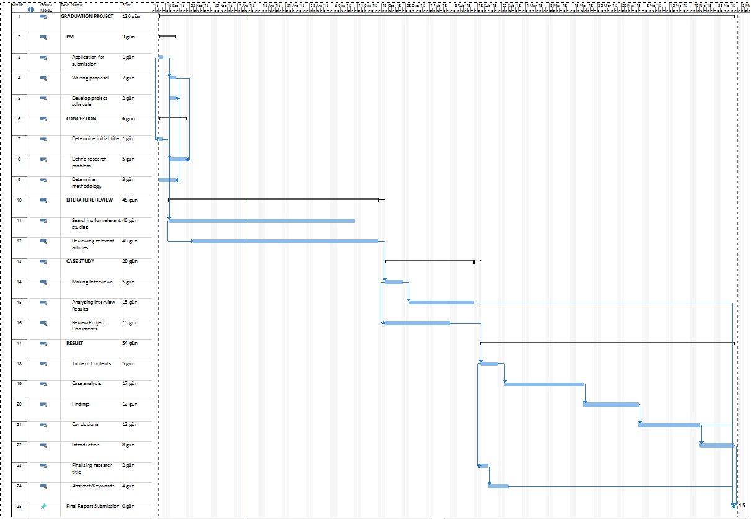
REFERENCES:

[1] Mack, N., Woodsong, C., MacQueen, K. M., Guest, G., & Namey, E. (2005). Qualitative research methods: a data collectors field guide
[2] Mehmet YITMEN, A.N., Bir Dönüşüm Hikayesi - Agile Proje Yönetimi, Seçkin Yayıncılık, Ankara, 2000.

[3] Mrs.Gunjan Behl , Mr.Nripesh kumar nrip :A study of Agile Software development model
[4] Swales, J. (1990). Genre analysis: English in academic and research settings. Cambridge University Press.

